2. For the virtual hosts mapped to the domains: [www.group4x.org](http://www.group4x.org)

* 1. Configure the virtual hosts to enable serving up compressed content to clients that are able to handle the compressed encoding. Limit the compression to HTML and CSS files only.
  2. Configure the virtual hosts to enable clients to cache PNG, JPG, and GIF files for up to 24 hours from the time they are accessed.

To enable serving up compressed content to clients, first , enable the compression features of IIS.

Go to **Windows Features** then expand Internet Information Services,World Wide Web Services and Performance Features. Check the Dynamic Content Compression and Static Content Compression.

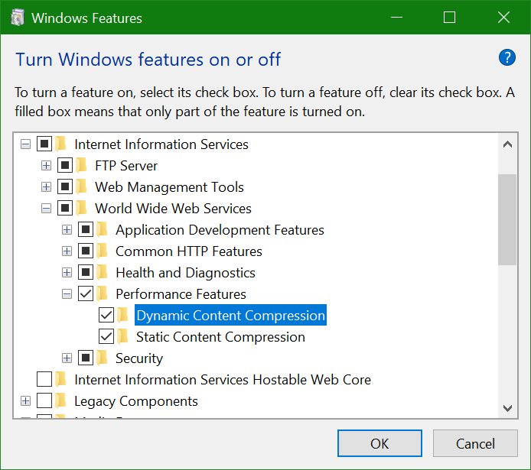

Go back to the IIS Manager, enter compression on the text field beside the label Filter then double click the **Compression.** Since css and html files are considered as static files(under MimeTypes) then check the static content compression.



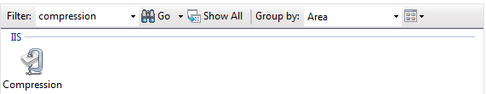

To enable clients to cache PNG, enter cache on the text field beside the label Filter then double click the Output Caching.

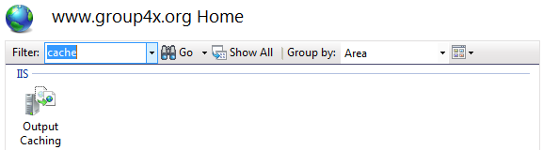

Click Add under the Action pane at the left side and enter the necessary details. Enter the filename extension of PNG file, which is “.png” and then check **User-mode caching.** Choose **At time intervals** and set it to 23:59:59 (since the value 24:00:00 is not valid).

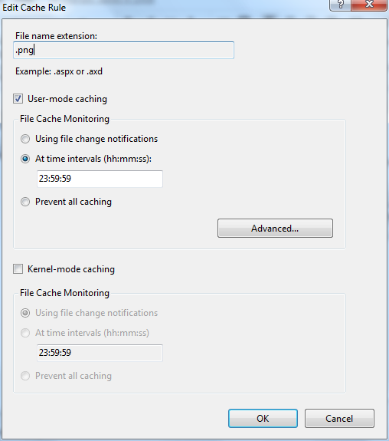

To enable clients to cache JPG, GIF and other files, follow the steps above and use the correct filename extension. After doing the same for JPG and GIF, we have the following

